Ten Big Ideas of Science

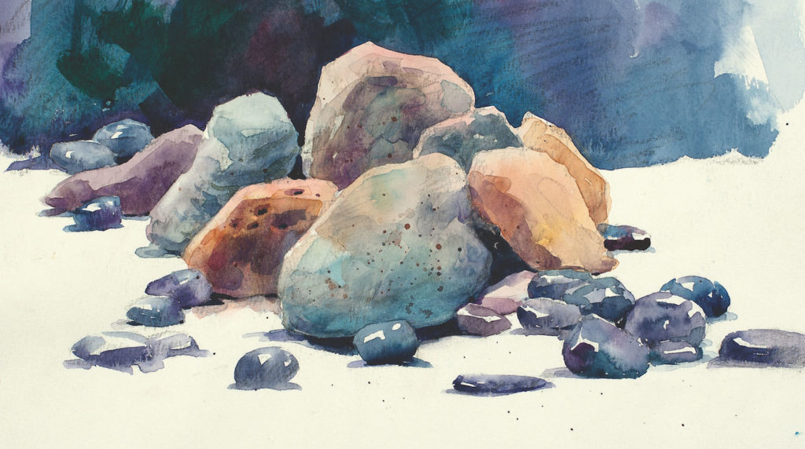
Ten Big Ideas of Science

