The science of COVID-19

Definitions
Coronavirus – A group of viruses with a halo of spiky proteins resembling a crown, which cause up to 30 percent of colds. This virus family also includes SARS and MERS.
SARS-CoV-2 – Severe Acute Respiratory Syndrome coronavirus 2, the name of the virus causing our pandemic
COVID-19 – Short for ‘coronavirus disease 2019’, the name of the disease
SARS – Severe Acute Respiratory Syndrome
MERS – Middle East Respiratory Syndrome.

NZASE Science Communicator Mike Stone outlines the science about the origin, transmission and prevention of COVID-19.

A pneumonia-like illness was nothing unusual during a winter December in a busy Chinese hospital. The Wuhan hospital received mainly older people, many with respiratory symptoms. The first known case of COVID-19 appeared on December 1, 2019, and the second a week later.
However, by December 12 the state broadcaster had reported a new viral outbreak in Wuhan city and nine days later the Chinese Centre for Disease Control and Prevention had identified a cluster of pneumonia cases of unknown cause. On December 31, China informed the World Health Organisation (WHO).

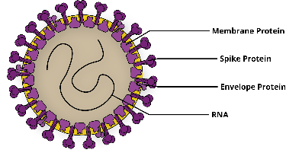
Type
Viruses are very simple pathogens consisting of genetic material surrounded by a lipid and protein coat. They need no organelles because they cause the cells they invade to make viruses. The main viruses that cause influenza (flu) in humans include rhinoviruses and coronaviruses.

Origin
Coronaviruses originate in animals and sometimes transmit to humans; SARS originated in bats and then infected palm civets before transmitting to humans. MERS also originated in bats and passed to camels, which transmitted the infection to humans.
The first SARS-CoV-2 infections were detected in patients who had visited a large seafood and live animal market in Wuhan. Chinese officials closed the market after notifying WHO, but scientists have yet to determine in which type of animal the virus originated. Some research suggests that it may have been passed from bats to pangolins (scaly anteaters) to humans.
Only about eight mutations (of a possible 30,000) have been found in the SARS-CoV-2 genome. By examining these mutations, scientists estimate that transmission from animals happened in October-November 2019.

How dangerous?
Usually coronavirus illnesses are fairly mild, affecting only the upper air passages. But SARS-CoV-2, as well as SARS and MERS, is different. These three types of coronavirus travel much further into the respiratory tract and attach to proteins on the outside of cells lining these airways. The 2019 version causes more lung disease than sniffles, and damage to lungs can make COVID-19 deadly.
Research (yet to be peer reviewed) estimates the mortality rate for confirmed cases of COVID-19 in China to be 1.4 percent¹, while WHO data suggests a global rate of 3.4 percent². This is at least ten times as lethal as seasonal flu (see table below), which kills up to 500 New Zealanders every year - Maori death rates in the 2009 influenza A outbreak were higher than for other ethnic groups. COVID-19 is slightly less deadly than the Spanish flu, which killed at least 9,000 New Zealand civilians and soldiers in late 1918; Māori had seven times the death rate of non-Māori.

A summary of virus outbreaks (P)= pandemic; H1N1 = refers to the pattern of spikes on the virus.
Virus outbreak | Origin | Date seen | Nos killed/infected | Proportion killed
SARS | China | 2003-2004 | 774/8096 | 10 %
MERS | Middle East | 2012-2015 | 858/2494 | 30 %
Spanish Flu H1N1 (P) | France | 1918-1920 | 50 million/?? | 2.5 %
Swine Flu H1N1 (P) | Mexico | 2009-2010 | 200,000/100 million | 0.02 %
Seasonal flu H1N1 A&B | Global | Every year | 650,000/?? | 0.1 %
How contagious?
SARS-CoV-2 is a new virus to which we have no immunity, so the infection initially spread very rapidly through human-to-human transmission. A newly infected person may be able to pass the disease to an average of up to 2.5 people³ (SARS could infect two to five, measles 12 to 18). People who are infected can transmit the virus to others even when showing no symptoms; this also makes them unlikely to be tested.
Respiratory droplets from an infected person’s cough or sneeze can carry human coronavirus to another person, usually a close contact. The virus typically only survives on a surface for a few hours⁴, but if we touch that surface and then touch our mouth, nose or eyes we may become infected.
Individuals who are older, immune-compromised, or have other medical conditions are particularly vulnerable to COVID-19. Data on 44,672 cases show that 81 percent are mild; 14 percent are severe, although most of these survive; five percent are critical; and 1.5 percent die⁵.

Disease progress
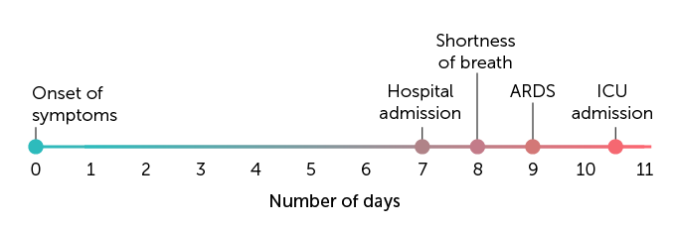
When a virus infects human cells, cells turn to making more virus particles which are then released, often rupturing cell membranes. In response the body makes cytokines, which alert the immune system to the presence of infection and put cells into a lock-down state so they are harder to infect. Large numbers of cytokines can cause high temperature, shakes and muscle aches; a severe response can damage infected tissues and the patient can sometimes die. There are as yet no treatments which can reduce this immune response.
Progression of severe COVID-19 cases.
The 1918 Spanish Flu strain seemed to trigger a particularly intense immune response, including a ‘cytokine storm’. Some scientists thought this explained why young, healthy adults – who normally find it easier to survive flu – were the worst affected, since their stronger immune systems created even more cytokines.
An infection with SARS-CoV-2 causes symptoms from two to 14 days after exposure, typically including fever, cough and fatigue, and sometimes headache and shortness of breath. Unlike SARS and MERS, COVID-19 rarely includes runny noses. Some patients develop pneumonia, and such lung damage can be deadly. Symptoms can intensify fairly quickly, resulting in hospital admission and acute respiratory disease syndrome (ARDS), where fluid builds up in the lungs, leading to severe shortness of breath. Some patients with COVID-19 have died from multiple organ failure.

Prevention
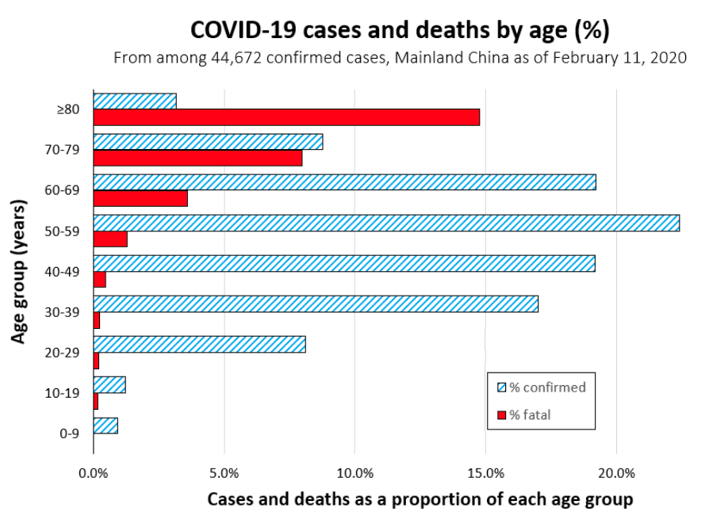
We can best protect ourselves from coronavirus or flu by washing our hands thoroughly with soap and water, which destroys the virus’ lipid coat, and drying them thoroughly; covering coughs and sneezes; not touching our eyes, nose and mouth; and staying at home when sick.
What about masks? Before any cases were confirmed in NZ, some residents bought stocks of surgical masks, which cover both mouth and nose, as a precaution. In many crowded Asian countries, people see it as polite to wear these masks to prevent the spread of germs by coughing or sneezing.
In hospitals, these loose masks are used for short periods by trained professionals, changed frequently, and disposed of properly. They are worn to stop droplets in the breath, or facial skin cells, falling onto patients in operations.
However, surgical masks do not protect the general public from the disease because the masks do not seal around the face, and have holes (5 microns) larger than a coronavirus (0.1 micron). Also, masks are usually reused, allowing microbes to build up on the outside; and wearers often touch the front of the mask when removing them, getting any virus particles on their fingers.
Surgical masks do, however, prevent infected people from shedding as many virus-containing droplets into the air around them, and prevents wearers from touching their mouth and nose.

Treatments
There are no specific treatments for COVID-19, and most people will recover on their own. Doctors can only treat the symptoms. Anti-biotics treat only bacterial infections - they are of no use against viruses. There is little evidence that other touted treatments, such as garlic, vitamin C and honey, have any impact. Tamiflu, an antiviral medicine used to treat influenza A and B in some people, did not work on SARS coronavirus, and is not likely to be effective here, although it is being tested.
Short-term solutions include using antibodies extracted from COVID-19 survivors, or made from samples of the new virus, which is being tested, and identifying and isolating those infected to stop the virus spreading.
Vaccines can build our immunity for some viral infections, but vaccines normally take years to develop and cost US$2.8 billion on average. Possible vaccine candidates need to be found and tested in animals, then in humans to ensure they are safe, that they work, and to find the ideal dose.
This process typically includes three consecutive sets of human trials, taking many years each, before the suitable vaccine can be mass produced and distributed. For example, a MERS vaccine was in phase II trials last year, seven years after the first case.
As of March 20, 2020, 44 candidate vaccines for SARS-CoV-2 were in human trials. For this pandemic, animal trials, phase I, II and III human trials, and manufacture are all starting at once, creating a huge financial risk for pharmaceutical companies.
This process has been simplified by the Coalition for Preparedness and Innovation (CEPI), a global partnership set up in 2017 to enable speedy development and fair distribution of pandemic vaccines. However, the most optimistic estimate is that a vaccine will not be globally available for 12 to 18 months - mid-2021 at the earliest.

Global response
On February 9, WHO declared COVID-19 a Public Health Emergency of International Concern (PHEIC) - a health issue that affects many countries by spreading across borders. This declaration gave the WHO more power to co-ordinate a global response with member states, including issuing travel advisories.
On March 11, WHO declared this outbreak a pandemic, which has a much wider spread than an epidemic. Epidemics are large outbreaks of a new disease confined to a specific region, like the early days of the outbreak in China. Epidemics become pandemics when several outbreaks continue on different continents, spread widely by human-to-human transmission that is not related to the country of origin.
Epidemics are generally considered to be containable, and pandemics are not. But the WHO says that this situation is different, and that it is still possible to contain the virus and mitigate its spread.
In a standard mitigation strategy, a country’s response intensifies as the cases increase, to prevent a spike in numbers beyond the health system’s ability to cope. Chinese and Italian data indicates that limiting activities to diagnosing and managing cases allowed case numbers to explode.
Eventually China contained the virus – reported deaths were only 3,230, much less that the seven million possible with a fatality rate of even one percent. However, some have questioned these figures.
Taiwan, Singapore and South Korea have also had very few people die of COVID-19. After their experience with SARS, these countries knew they had to prioritise public health over individual liberty, with the willing co-operation of a well-informed public with experience of stringent government controls.
These countries quickly closed their borders to China, focussing on rapid early diagnosis of as many cases as possible, strict home quarantine, and rapid early isolation of all contacts of infected people.
Overseas experience of COVID-19 shows that about 20 percent of the population will need to be hospitalised, five percent will need intensive care, and one percent will need a ventilator to help them breathe⁶.
But New Zealand has limited intensive care beds (176) and ventilators (520). So the government chose an eradication strategy – to eliminate the chains of transmission by isolating everyone at home, including all students, leaving only essential services and supply lines running. In an island nation like ours, this approach makes much more sense.

Scientists
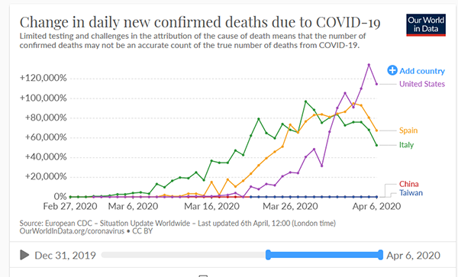
Just ten days after China informed WHO of the outbreak, a Chinese virologist uploaded the entire SARS-CoV-2 genetic sequence into the public domain to allow the world’s scientists to work towards solutions, at a speed seen in no other outbreak. But what happened next was unprecedented.
Scientists around the world immediately started work in their specialist areas. The exceptional transparency of many authorities enabled the almost overnight development of test kits for diagnosing people and defining cases. CEPI as well as many researchers, journals and funders have enabled research results and information relevant to the outbreak to be shared quickly and openly.
However, a result of the shorter time for peer review has meant that some potentially unreliable information has become public. For example, a study about the use of chloroquine as a treatment, endorsed by President Trump in a tweet, led to the deaths of several people who used it treat themselves. Other scientists have since challenged this research.
WHO has recommended evidence-based protocols for diagnosing, treating and limiting the spread of COVID-19, but not all countries are following them. For example, America developed a different diagn0ostic test, which gave inconclusive results and had to be redesigned.
Vaccine development has been extremely fast, due to unique co-operation between the WHO, countries, scientists and industry. WHO is co-ordinating research to ensure a transparent selection of vaccine candidates for further testing.
SARS, MERS and Swine flu have taught scientists to collaborate on a far wider scale to solve global health problems. And that will stand us in good stead as scientists work together to fight this pandemic.

Links
COVID-19 resources in te reo Māori
Government’s COVID-19 site
WHO COVID-19 pages
Information is beautiful: COVID-19 data pack
Our world in data: Change in daily new confirmed deaths from COVID-19.

Ngā Kupu

Huaketo - Virus
Ngā kaipūtaiao - Scientists
Mātai tahumaero - Epidemiology
Mate hōrapa - Infectious disease
Mate rere - Contagious disease
Mate urutā - Epidemic, pandemic
Rewharewha - Influenza
Tukumate - Pathogen, infectious agent
Wāhanga whāomoomo - Intensive care unit

Footnotes
1 R. Verity et al. (2020). Estimates of the severity of coronavirus disease 2019.
2 WHO (2020). Director-General’s opening remarks at the media briefing on COVID-19.
3 The Atlantic. (2020). The deceptively simple number sparking coronavirus fears.
4 S. Wiles. (2020, March 21). A reminder that Covid-19 still isn’t airborne.
5 Information is beautiful. (2020). COVID-19 data pack.
6 S. Wiles. (2020). After ‘Flatten the Curve’, we must now ‘Stop the Spread’.

References
The Atlantic. (2020). The deceptively simple number sparking coronavirus fears.
Australia’s Science Channel. (2020, March 12). A vaccine against the virus that causes COVID-19 just took a huge step forward.
M. Baker. (2020, March 30). ‘Overjoyed’: a leading health expert on New Zealand’s coronavirus shutdown, and the challenging weeks ahead. SciBlogs.
Drs Michael Baker & Trang Khieu, in S. Blundell. (2019). The evolving threat of influenza. NZ Listener.
H. Branswell. (2020, February 6). In effort to develop coronavirus vaccine, outbreak expert sees ‘hardest problem’ of his career. Stat.
S. Braunias. (2020, March 25). Covid 19 coronavirus: Kiwi virologist who knew ‘angel of death’ on way. NZ Herald.
NZ Herald. (2020, March 24). Covid-19 coronavirus: The science of soap.
Centers for Disease Control (CDC). (2020). Coronavirus disease 2019 - Frequently asked questions.
CDC. (2020). How COVID-19 spreads.
Compound Interest. (2020, January 22). The viruses behind colds and flu.
E. de Jesus. (2020, February 3). SARS and the new coronavirus target the same cellular lock to infect cells. Science News.
R. Fischer. (2020, March 12). What’s the difference between pandemic, epidemic and outbreak? SciBlogs.
C. Hadavas. (2020, March 11). How Taiwan and Singapore have contained the coronavirus. Slate.
H. P. Harris. (2020, February 26). Beating the evolving COVID-19 pandemic – unprecedented human collaboration in discovery and innovation. SciBlogs.
H. P. Harris. (2020, March 31). Smashing down the barriers: Where are we at with COVID vaccines? SciBlogs.
P. Hill. (2020, March 13). New Zealand’s COVID-19 public health response must be aggressive. SciBlogs.
IFLScience! (2020, February 7). Pangolins may have played a key role in the coronavirus outbreak, say Chinese scientists.
Information is beautiful. (2020). COVID-19 data pack.
John Hopkins. (2020). Coronavirus resource centre.
R. Jones. (2020, March 18). Why equity for Māori must be prioritised during the Covid-19 response. The Spinoff.
LiveScience. (2020). Coronavirus outbreak: Live updates.
J. Lambert. (2020, March 11). What WHO calling the coronavirus outbreak a pandemic means. Science News.
Ministry of Health. (2020, February 25). COVID-19 update.
B. Mole. (2020). Don’t panic: The comprehensive Ars Technica guide to the coronavirus. Ars Technica.
New York Times. (2020, February 5). Why the new coronavirus (mostly) spares children.
NZ Herald. (2020, January 28). Coronavirus panic: Face masks sell out, but do they work?
S. W. X. Ong, et al. (2020). Air, surface environmental, and personal protective equipment contamination by Severe Acute Respiratory Syndrome Coronavirus 2 (SARS-CoV-2) from a symptomatic patient. JAMA. doi:10.1001/jama.2020.3227
C. Pillar. (2020, March 26). ‘This is insane!’ Many scientists lament Trump’s embrace of risky malaria drugs for coronavirus. Science.
RadioNZ. (2020, January 25). Coronavirus latest: virologist Chris Smith.
RadioNZ. (2020, March 24). 153 intensive care beds in country – survey.
D. Robson, (2018, October 31). Why the flu of 1918 was so deadly. BBC.
T. H. Saey. (2020, January 24). How the new coronavirus stacks up against SARS and MERS. Science News.
Science News. (2020, January 29). Your most pressing questions about the new coronavirus, answered.
D. Smith. (2020). Update: County positive COVID-19 cases rise to 56. Kenosha News.
University of Otago. (2020, March 19). Rapid case contact management – COVID-19’s achilles heel?
N. van Doremalen et al. (2020). Aerosol and surface stability of SARS-CoV-2 as compared with SARS-CoV-1. New England Journal of Medicine.
R. Verity et al. (2020). Estimates of the severity of coronavirus disease 2019: A model-based analysis. Lancet: Infectious diseases.
N. Wetsman. (2020, March 17). Coronavirus testing shouldn’t be this complicated. The Verge.
WHO. (2020). Global research on coronavirus disease (COVID-19).
WHO. (2020, April 4). Coronavirus disease (COVID-2019) situation reports.
S. Wiles. (2020, January 21). The emerging coronavirus outbreak in China. SciBlogs.
S. Wiles. (2020, January 22) The Chinese coronavirus outbreak: What are the options for vaccines and treatments? SciBlogs.
S. Wiles. (2020, February 16). Coronavirus update: Spread outside China and a new name. SciBlogs.
S. Wiles. (2020, March 14). After ‘flatten the curve’, we must now ‘stop the spread’. Here’s what that means. SciBlogs.
S. Wiles. (2020, March 21). A reminder that Covid-19 still isn’t airborne. The Spinoff.

