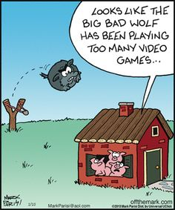
What does this mean for me? Inferences

What might this mean for your science teaching practice?

What opportunities do you have in the next few weeks that will give your students a chance to think about scientific inferences?

What observations might they make?

How might you bring out their prior knowledge?

Think of 1 or 2 questions you might ask students to help them make their inferences

What ways of checking might your students come up with for checking their inferences?

Sort the possible ways of checking into two categories; Those they can do and those they can’t.
This decision will depend on safety requirements and resources you have or resources that can be adapted for purpose.

Which other learning areas might also benefit from using a similar process for inferences?

