🌍 Human Dispersal Theories – Classroom Handout
This resource explores the two main theories of human dispersal: Out of Africa and Multiregional Evolution. It presents key evidence for each theory, with explanations and examples, to support Year 13 students in an expert groups activity for Achievement Standard 90719.

Out of Africa Theory – Strongest Evidence

Oldest Homo sapiens fossils in Africa
The oldest modern human fossils are found in Africa. The Omo Kibish fossils in Ethiopia are around 195,000 years old, and the Herto fossils, also from Ethiopia, are about 160,000 years old. These are clearly recognisable as Homo sapiens. Outside Africa, the earliest modern human fossils are much younger – for example, in Israel (~90,000 years ago) and in France (~40,000 years ago, Cro-Magnon remains). This suggests that Homo sapiens evolved first in Africa and later spread elsewhere.

Mitochondrial DNA (“Mitochondrial Eve”)
Mitochondrial DNA (mtDNA) is passed only from mothers to their children. Studies show that all humans today can trace their mtDNA back to a single woman who lived in Africa around 150,000–200,000 years ago, often called “Mitochondrial Eve.” She was not the only woman alive at the time, but her lineage is the one that survived. The deepest mtDNA branches are found in Africa, while non-African lineages are fewer and younger. This strongly supports an African origin for modern humans.

Greatest genetic diversity in Africa
Genetic diversity is highest in Africa, meaning African populations show the greatest DNA variation. The longer a population has existed, the more mutations and variation it will have. For example, the San (Bushmen) people of southern Africa have the highest known levels of genetic diversity. In contrast, European, Asian, and American populations have smaller subsets of this variation. This pattern suggests all non-African groups are descended from smaller groups that left Africa, backing the Out of Africa model.

Y-Chromosome “Adam”
The Y-chromosome is passed from father to son. Research shows that all men alive today trace their Y-chromosome back to a man who lived in Africa about 200,000 years ago, nicknamed “Y-Chromosome Adam.” Like “Mitochondrial Eve,” he was not the only man alive, but his Y-lineage is the one that survived. The oldest Y-lineages are found in Africa, while non-African lineages are younger and derived from them. This evidence again points to Africa as the origin of modern humans.

Archaeological evidence of modern behaviour
The earliest evidence of symbolic behaviour and culture comes from Africa. At Blombos Cave in South Africa (70,000–100,000 years old), archaeologists found engraved ochre, shell beads, and bone tools. These show abstract thinking and symbolic culture. Outside Africa, similar evidence – like European cave art at Lascaux – only appears around 20,000 years ago. This suggests complex behaviour developed in Africa first, before spreading with migrating humans.

Genetic bottleneck outside Africa
When small groups left Africa, they carried only part of the genetic diversity of the African population. This “genetic bottleneck” or founder effect means non-African populations have lower genetic diversity than African ones. Modern genetic studies show a clear drop in diversity the further populations are from Africa. This matches the idea of a single origin in Africa, followed by dispersal.

Multiregional Theory – Strongest Evidence

Continuity of traits in East Asia
Certain traits appear to persist across long periods in East Asian fossils. For example, Homo erectus fossils from China (Zhoukoudian, ~700,000 years old) show shovel-shaped incisors, a trait still common in many East Asians today. Supporters of multiregionalism argue this suggests regional continuity, not full replacement by African migrants. While critics say gene flow could explain this, the persistence of such features is used as evidence for local evolution.

Continuity in Australia
Some ancient Australian fossils, like those from Kow Swamp (~13,000 years old), have very robust skulls with thick bones and heavy brows. These resemble earlier Homo erectus fossils from nearby Java more than modern humans from other regions. Multiregionalists use this as evidence of continuity between regional populations and modern Aboriginal Australians, suggesting at least partial local development rather than total replacement.

Neanderthal DNA in modern humans
Genetic research shows that non-Africans today carry 1–4% Neanderthal DNA. This proves modern humans interbred with Neanderthals after leaving Africa. A child skeleton from Portugal (~24,000 years ago) even shows mixed Neanderthal and modern features. This overlap and interbreeding supports the idea that humans did not simply replace each other, but exchanged genes, as the multiregional model proposes.

Denisovan DNA in modern humans
Another archaic human group, the Denisovans, contributed DNA to modern populations. Fossils from Siberia (~50,000 years ago) revealed their existence. Today, Melanesian and some Southeast Asian populations carry 4–6% Denisovan DNA. One Denisovan gene even helps Tibetans survive at high altitudes. This proves interbreeding between modern humans and regional archaic humans, supporting multiregionalism’s emphasis on gene flow.

Regional fossil similarities
Some fossils show a mix of archaic and modern traits, suggesting gradual regional evolution. For example, the Dali Man fossil from China (~200,000 years old) has both archaic and modern features. Multiregionalists argue this shows continuity from Homo erectus to modern humans in East Asia. Critics suggest these could be early migrants from Africa, but the regional pattern is used to support local contributions.

Overlap between archaic and modern humans
In Europe, Neanderthals and modern humans coexisted for thousands of years. At Vindija Cave in Croatia, Neanderthal remains overlap in time with early modern humans. This created opportunities for interbreeding, as confirmed by DNA studies. Multiregionalists argue this overlap shows blending rather than total replacement, fitting their model of regional continuity with gene flow.

✅ Current View
Most scientists now accept a “Mostly Out of Africa” model. This means modern humans evolved in Africa and dispersed around the world, but they also interbred with local archaic populations such as Neanderthals and Denisovans. This explains why genetic and fossil evidence points to an African origin, while also showing regional contributions.

💡 Activity Suggestions for Expert Groups
- Group Task: Each group studies one piece of evidence in detail (from the sections above).
- Teach Back: Groups explain their evidence to others, showing how it supports one theory.
- Compare & Contrast: As a class, map out which evidence best supports each theory and which pieces overlap.

❓ Check Your Understanding
- Why are the oldest Homo sapiens fossils important for supporting Out of Africa?
- How do mtDNA and Y-chromosome studies support an African origin?
- What does the presence of Neanderthal and Denisovan DNA in modern humans suggest?
- Why do some scientists prefer a “Mostly Out of Africa” model instead of one extreme theory?

🔹 Suggested Diagrams & Visuals

1. World Map of Human Migration (Out of Africa)
- Arrows showing dispersal routes out of Africa (~60–70,000 years ago).
- Highlight Africa as the origin point.
- Include major fossil sites (e.g., Omo Kibish, Herto, Skhul, Cro-Magnon).
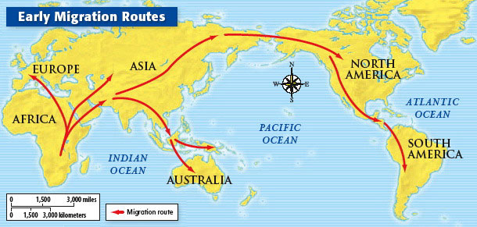

2. Fossil Timeline
- Horizontal timeline with fossils plotted by age and location.
- Show Omo Kibish (~195k), Herto (~160k), Skhul/Qafzeh (~90k), Cro-Magnon (~40k).
- Helps students visually compare “older in Africa, younger outside.”

3. Genetic Tree (Mitochondrial DNA & Y-Chromosome)
- Tree diagram tracing modern human lineages back to “Mitochondrial Eve” (~150–200k, Africa) and “Y-Chromosome Adam.”
- Show deeper branches in Africa, with fewer branches outside Africa.

4. World Map of Genetic Diversity
- Map shaded to show genetic diversity (darkest in Africa, lighter outside).
- Arrows indicating founder effects (bottlenecks) as humans left Africa.
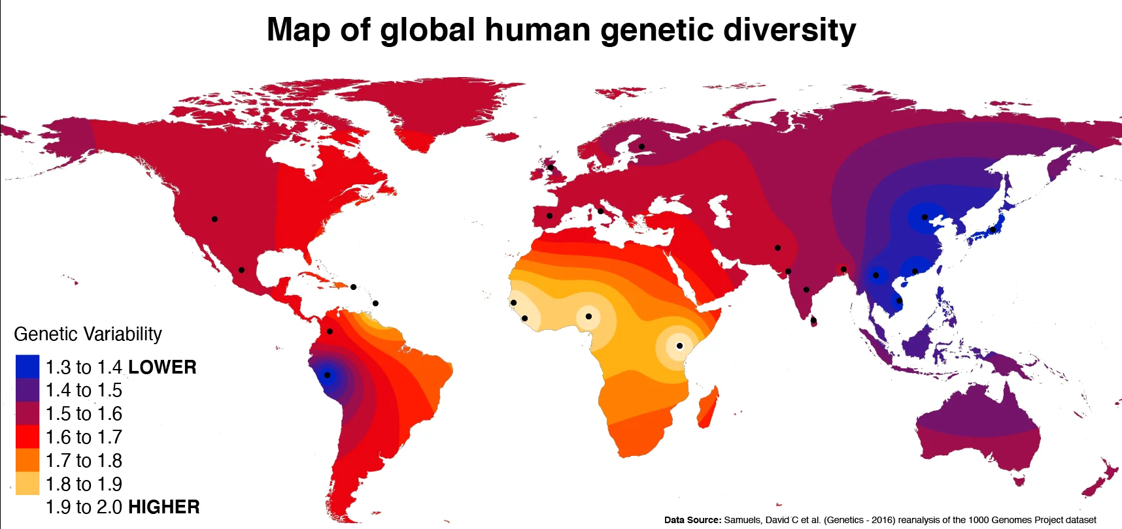
https://preview.redd.it/25g0zz33o2z61.png?auto=webp&s=98b0c38d68ea872cd13d886eb2f5c540a780c9be

5. Neanderthal & Denisovan DNA Contribution
- Diagram showing % of archaic DNA in modern populations:
  - Europeans: ~1–4% Neanderthal
  - East Asians: ~2–4% Neanderthal
  - Melanesians: ~4–6% Denisovan
- Could be a simple bar chart or pie slices.

6. Skull Comparisons
- Side-by-side illustrations of:
  - Homo erectus
  - Neanderthal
  - Early Homo sapiens
  - Modern human
- Helps students see continuity vs differences.
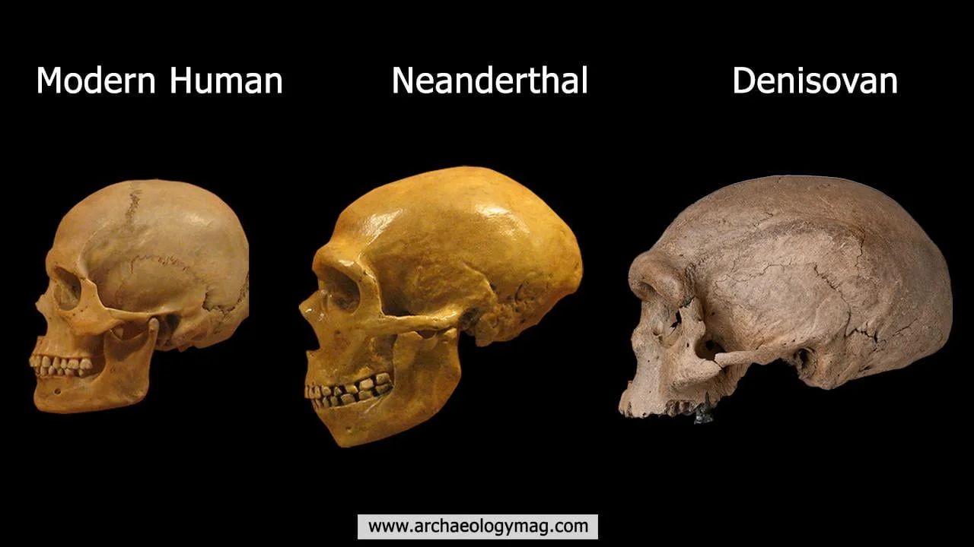

7. Map of Overlap Zones
- Europe and Asia shaded to show areas where Neanderthals, Denisovans, and modern humans overlapped.
- Mark caves like Vindija (Croatia) and Denisova (Siberia).